INSTRUCTOR:

{MA’AM SAFIA SHAIKH}

STUDENT:

{HEER KASHIF}

ROLL NO:2025/AI/46

PROGRAM:01

Write a python program that takes the user’s name as input and then prints a greeting message like ”Hello,Ali”

INPUT:
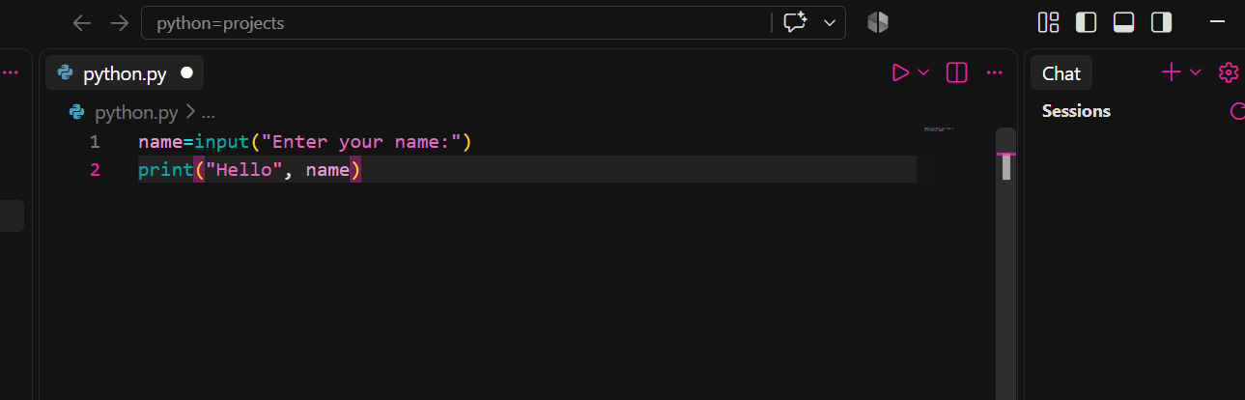

OUTPUT:
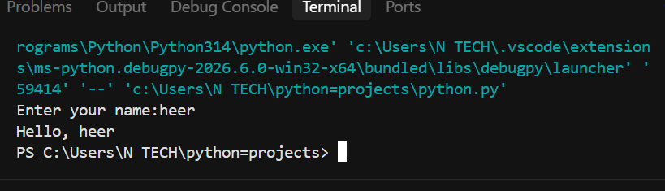

PROGRAM:02

Write a python program that takes hours worked and hourly rate as input from the user,then calculates and display the gross pay.

INPUT:
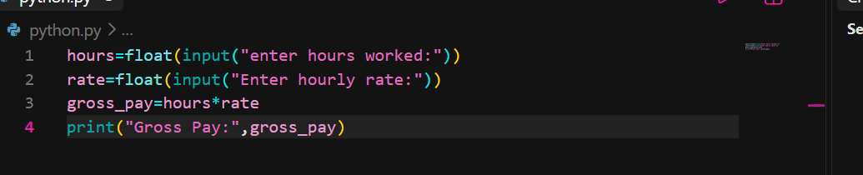
OUTPUT:
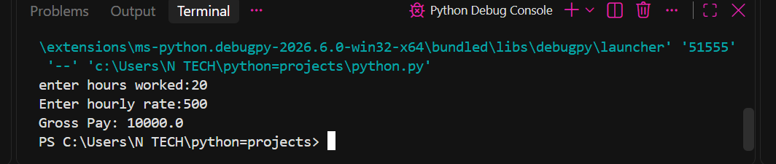

PROGRAM:03

Write a python program that takes temperature in Celsius as input from the user and converts it into Fahrenheit
INPUT:
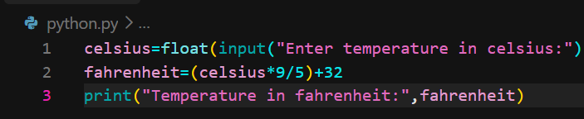
OUTPUT:
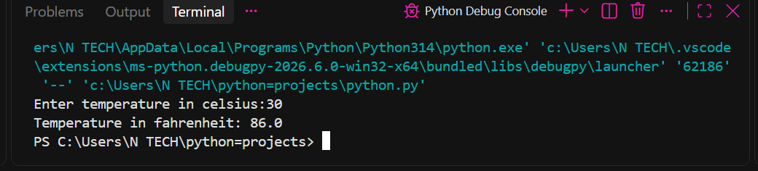

PROGRAM: 04,

Write a Python program that takes two numbers as input and calculates the first number raised to the power of the second number (exponentiation).
INPUT:
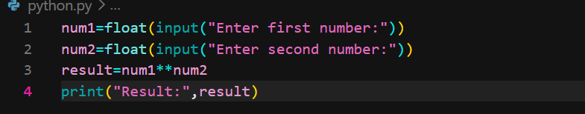
OUTPUT: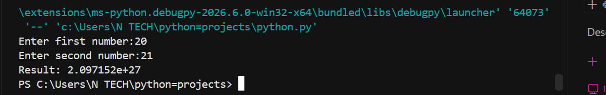

What does the following Python code do? Explain the type conversion that happens in this program?
AGE= 20
ITEM= 5
Print (“age:”,age)
Print (“item:”,item)

Age = float(age)
item= float(item)
Print (“age:”,age)
Print (“item:”,item)
Input:
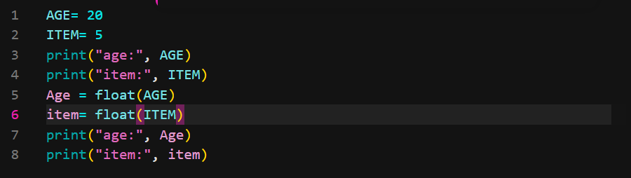
EXPLAINATION:
- Initially, age = 20 and item = 5 are integers (int).
- The first print () statements display:
Age : 20
Items : 5

Then float (age) and float (item) convert the integers into floating-point numbers (float).
• So 20 becomes 20.0, and 5 becomes 5. 0.
• The final output is:
OUTPUT:
